**PDA Flexible Ticket System**

3rd .Semester Project

Team5, PROI3 IT-Project

|  |  |
| --- | --- |
| **Supervisor(s):** |  |

Svend Mortensen – DIST3

Ole Rydahl – NET3

Roger Munck Fairwood – COMP3

|  |  |  |
| --- | --- | --- |
| **Student name** | **Student number** | **Signature** |
| **James Testmann**  **Lukas Janocko**  **Shicheng Dai**  **Sudhir Chaurasiya**  **Aimo Suikkanen** | **S071954**  **S135272**  **S133342**  **S137239**  **S082577** |  |
|  |  |  |
|  |  |  |
|  |  |  |

Table of Contents

1. Introduction 2

2. Problem Formulation 3

3. Requirements specification 3

3.1.1 Functional requirements 3

3.1.2 Non-functional requirements 4

4. Problem analysis and solution 5

4.1.1 System Description 5

**4.1.2** **Main Server** 5

**4.1.3** **System Distribution** 7

**4.1.4** **Travel plan** 7

**4.1.5** **A* Algorithm** 7

**4.1.6** **Use Case Diagram** 11

**4.1.7** **State chart and activity diagrams** 20

**4.1.8** **Proprietary protocol** 24

**4.1.1** **Home JSP** 27

**4.1.2** **Sign up process** 27

**4.1.3** **Login JSP** 29

4.1.4 Logout JSP 30

**4.1.5** **Conclusion** 30

4.1.6 Product Evaluation 30

4.1.7 Process Evaluation 31

# Introduction

This project intends to develop a prototype for a flexible ticket system.

Can be used in buses and trains. The system must operate so that customers are not physically must check in and out on buses and trains. This must be done by the customer’s PDA.

To communicate with the bus / train and automatically check in without the customer having to do anything. This communication will be through Bus / train LAN connection.

Servers and train computers should be located on our virtual servers (“thelizard6”) and use relevant DBMSs – MySQL. It is however acceptable to use a number of a team’s portable computers as bus / train computers.

After completion of travel, the system itself could calculate the price of the journey made, and withdraw this amount from the customer Account.

During the journey the customer should always be able to see its provisional Zone structure.

It will also develop a travel plan, which customers can use to calculate

the quickest route to their destination. This itinerary must be kept updated with delays and cancellations, so the customer will always get the fastest route based on the current traffic situation.

Customers should be able to log on to a website where they will be

register before they can use the system. This website also

Customer to view account balance, fullness money in the account and correct Personal information.

# Problem Formulation

Project tells the details about the new ticketing system for making the life easier to without doing physical interaction.

Public ticketing system where customers come to be recorded automatically by the buses or train. By doing this facilitates the Customers know that, they should not have to think about buying a ticket or scan in and out in each station.

For this to be done, there are a number of major issues to be

answered. It includes:

* How to register customer PDAS?
* Where to users' information stored once they have been registered of a bus or a train?
* How do we handle many trains / buses close to each other?
* The customer is registered on the correct transport?
* Where and how is the payment handled?
* How is a route calculated?
* How should the total distributed so that the system is as effective as Possible?

**1.2 The Problem Boundary**

The system is being developed is a prototype. The goal is to establish a system

The PDA part is not an app, but also simulated on a PC.

# Requirements specification

### Functional requirements

**Criteria:**

• Give the customer/client an easy and user experience.

• Design the system to require minimal user interactions.

|  |  |
| --- | --- |
| **Requirements** | **Description** |
| R1 | The customer must be able to create a user via the website. |
| R2 | Client’s PDA to registration by BTC at out and input by train/bus |
| R3 | Customer must be able to log out /in its user |
| R4 | The customer must be able to deposit money into their user account |
| R5 | Client must be able to see his balance from his user account |
| R6 | The customer must be able to correct its information on the website |
| R7 | The client must be able see the price of its provisional travel at any time |
| R8 | The Customer must present a ticket on his PDA |
| R9 | The customer shall be automatically deducted from the price of the trip |
| R10 | The customer should be able to find the fastest trip e.g. from A to B from travel plan |
| R11 |  |
| R12 |  |

A customer needs to see and correct the information and requirements are designed.

So that the customer can find the information that is needed. This means that

System to meet all the requirements a customer has to make a journey.

### Non-functional requirements

|  |  |
| --- | --- |
| **Requirements** | **Description** |
| NFR1 | BTC(**BUS TRAIN SERVER)** will be developed in Java |
| NFR2 | Main Server to be developed in Java |
| NFR3 | Proprietary protocol to be developed in java |
| NFR4 | Algorithms for travel plan and price calculator to be developed in Java |
| NFR5 | The database will be developed in MySQL |
| NFR6 | The site should be developed with JSP and servlets |
| NFR7 | Socket to be used for the server |
| NFR8 | server must be on the DTU server |

# Problem analysis and solution

### System Description

The system shall consist of six parts:

* Database
* Main server
* Bus / train computer (BTC)
* Website
* PDA
* Proprietary protocol (between BTC and PDA)

### **Main Server**

* Main server to process all the requests coming from BTC.
* The server must be multithreaded so it can process multiple requests simultaneously.
* Main server are on the DTU servers.

**3.1.2 BTC**

* Each bus or train will be installed with a BTC (Bus Train Computer).
* When the bus / train stops at a bus stop will BTC record all the customers who have gone on board the bus / train.
* For this communication, there is developed a proprietary protocol.
* BTC stores cached user information and sends to the main server.
* Main server verify all the customers and sends this information back to BTC.

**3.1.3 PDA**

PDA is the customer's smartphone / pocket computer which is used to register

On buses and trains.

And show status to conductor.

**3.1.4 The website**

The website is developed with JSP/Servlet (Java Server Page).

On the website, customers can create a user and once the customer has been registered successfully afterwards can be able to use the website through the process using Login system.

Change user info, see the travel history and time schedule.

### **System Distribution**

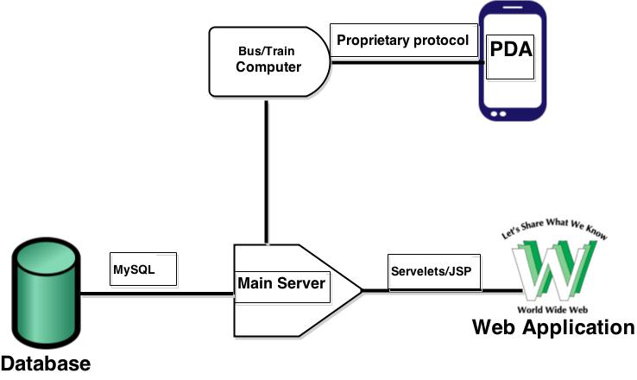

### **Travel plan**

This project require us to solve the problem by developing an application equivalent to Itinerary and this must be dynamic in relationship to the current traffic situation. The following is a summary of the design process.

### **A* Algorithm**

Before start the coding, the first step for find the solution is to be a suitable algorithm to find the fastest/shortest route between two points. The followings are the advantages and disadvantages:

|  |  |  |
| --- | --- | --- |
| **Algorithm** | **Advantages** | **Disadvantages** |
| **Best first** | Always find the best node in relationship to the previous one | Not checking its position in relationship to the start node |
| **Dijkstra** | Find the distance to each node only from the starting point | Work out from the starting node and have no direction. |
| **A\*** | -It is always ready over the distance from the starting node to the current node.  -Determine the next node out from a related value (heuristic) to the ending node. | Maybe stay visited in "dead ends" |

We decided to select **A\*** algorithm when is a combination of **Dijkstra** and Best first as our way to find the **fastest/shortest** path. It is also an algorithm often used to find the fastest and shortest path. Although it has some disadvantages, due to most of the advantages combined together with other disadvantages of algorithm. A* is enough to handle the best because it always has track on where is the relationship between the starting node and the ending node (estimate). When there happens a change will be the only one lead you without "problem” and find a new fastest/shortest path again.

**3.1.2 Database analysis and Design**

As our lot of discussion to DBMS finally we reached on the specific point. The problem statement, it appears that the database must be accessible from many different applications through the server, making the design of the database is very important for instance, to avoid duplicate entries and tables are the same. The database is set up on the server set available at the DTU “thelizard6". It is made with MySQL as it is a good free database service. In the Other hands to select thelizard6, the server is preloaded with two database handlers, MySQL and PostgreSQL. The MySQL is preferred as this database is being taught in depth during the project.

To reduce strain on one database, more databases are created for the purpose having one database with the customer information, one database with the travel history of every customer and one database containing station names.

The CustomerInformationDB contains a unique customer id, the first name, last name and email. The customer id is auto generated for each added customer. A precondition is that emails are personal and unique, therefore the email is also a unique identifier, and making sure a customer is not signed up with two accounts. This gives the option of two customers with identic names can sign up without interfering with each other’s account.  
A customer could sing up with two different emails, and disregard the purpose of a unique email as a customer identifier. This could be prevented by using social security numbers, but in this project there is no option for requesting a check on a social security number.

The stationDB contains a name for each station, but also a unique station number, making it possible for two stations to have the same name, but still be uniquely identified.

The TravelDB is going to be the largest of the databases, containing information about date, start time, start station, end time, end station, number of zones, cost of travel, customer id and travel number.  
The date and travel number are mainly used for statistics.  
The start and end station is the station number, used to calculate the number of zones travelled.  
The start and end times gives the travel duration, which is then compared to the number of zones travelled and the appropriate price can then be calculated. **Zones is calculated as   
|EndStation - StartStation|= Zones. The Price is calculated to be 20, - pr. Zone.  
The customer id is used to tie a customer to a specific travel, making it easier to calculate price on demand.**

This is wrong!!!

Erase it

**3.1.3 Database package**

|  |  |
| --- | --- |
| **Class:** **DataBaseHandling** | **Collaboration** |
| This class is the interface implemented by DatabaseHandler class. | Customer Collect Thread clientDatabaseHandler |

|  |  |
| --- | --- |
| **Class:** **DatabaseHandler** | **Collaboration** |
| This class has all the methods that retrieve / store data in the database. | DataBaseHandling |

|  |  |
| --- | --- |
| **Class: PostgresqlConnection** | **Collaboration** |
| This class is making connection between to our system for process all the data. | DatabaseHandler |

|  |  |
| --- | --- |
| **Class:** **User** | **Collaboration** |
| This class is the interface implemented by UserImp class. | This class has field, constructor, getter and setter for making available for doing the process in DatabaseHandler class. |

### **Use Case Diagram**

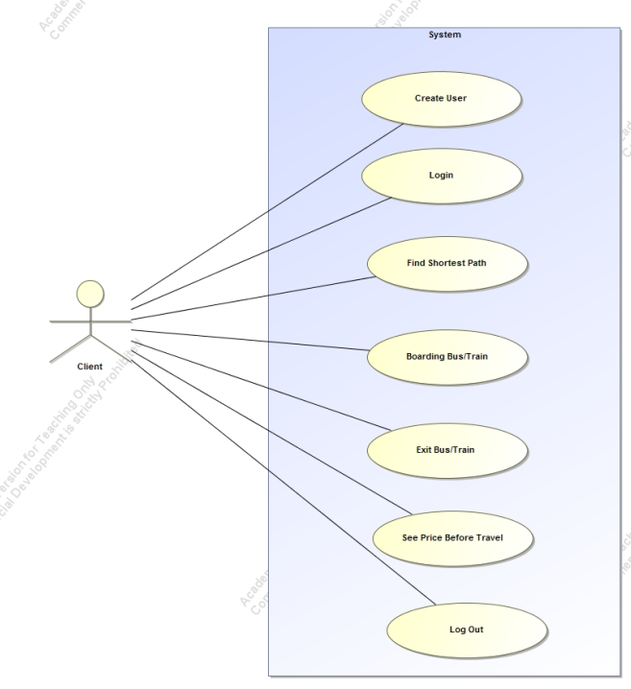

|  |
| --- |
| **UC1:** *Log in* |
| **Brief description:**  Customer should be able to login. |
| **Actors:**  *Customer* |
| **Preconditions:**  *The users can see that in the homiside of log in website.* |
| **Main flow:**  1. This use case starts when the user wants to log into the system. 2. The correct firstName and password is entered. 3. The system checks if password is equal to the corresponding user. 4. If the password is correct, then the user has the permission to log in.  5. The user comes to the homeside. |
| **Post conditions:**  *Users log in after entering the right password and firstName.* |
| **Alternative flows:**  1. The user enters the wrong code. 2. The system checks if password is equal to the corresponding user. 3. The user is told that the password is wrong and that the password must be entered again. |

|  |
| --- |
| **UC2:** create User |
| **Brief description:**  *If users have no account, users can register accounts.* |
| **Actors:**  *Customers* |
| **Preconditions:**  *The customer will be connected to the website.* |
| **Main flow:**  1. This use case starts when a customer wants to use the travel card. 2. The customer chooses to create. 3. The customer enters their information. 4. The system stores all information in the database. 5. The system may provide instructions to the user is created |
| **Post conditions:**  *The customer is created and the customer's data is stored in the database.* |

|  |
| --- |
| **UC3:** Updating customer information |
| **Brief description:**  The customer can be able to update customers' information. |
| **Actors:**  customer |
| **Preconditions:**  The customer is logged in on the website. |
| **Main flow:**  1. Customers can change their information. 2. The system will find the customer information from the database. 3. The system changes the information in the database. 4. Customer will be informed that the information is updated. |
| **Post conditions:**  Customer has updated its information. |
| **Alternative flows:**  1. The customer presses cancel. 2. The customer will be notified that the update is interrupted. |

|  |
| --- |
| **UC4:** Boarding the bus or train |
| **Brief description:**  A customer should be automatically registered when boarding a bus or train. |
| **Actors:** *Customer* |
| **Preconditions:**  The customer's PDA is enabled. |
| **Main flow:**  1. This use case starts when a customer embarking on a bus or train. 2. BTC detects that the client is on board. 3. The system retrieves the customer's initial travel and caches this in BTC server. |
| **Post conditions:**  The customer is detected boarding on the bus or train. |
| **Alternative flows:**  If customer the PDA.  Customer will not able to connect to the system.  Customer will have to go to the further registration process. |

|  |
| --- |
| **UC5:** See preliminary price of travel |
| **Brief description:**  Before customer starts travelling, customer can check the price of where the destination is |
| **Actors:**  *Customer* |
| **Preconditions:**  The customer is on a bus or train. |
| **Main flow:**  1. This use case when the customer chooses to see it’s provisional. 2. Prices will be displayed on the website 3. Journey preliminary cost will be shown on the PDA |
| **Post conditions:**  Customers are still on the bus or train. |
| **Alternative flows** |

|  |
| --- |
| **UC6:** see balance |
| **Brief description:**  A customer should be able to see his balance. |
| **Actors:**  *Customer* |
| **Preconditions:**  The customer is logged in to the site |
| **Main flow:**  1. This use case starts when the customer chooses to see his balance 2. The website takes the customer's balance from the database 3. The balance is displayed on the home website. |
| **Post conditions:**  The customer is the home page |
| **Alternative flows:** |

|  |
| --- |
| **UC7:** Find the shortest route |
| **Brief description:**  A customer should be able to find the quickest route on the website |
| **Actors:**  *Customer* |
| **Preconditions:**  The customer is logged in to the site |
| **Main flow:**  1. This use case starts when the customer chooses to find the fastest route in the the website 2. The customer selects the two stops he will soon find route 3. The website will find the fastest route and displays it on the website |
| **Post conditions:**  The customer is on the website. |
| **Alternative flows:** |

|  |
| --- |
| **UC8:** Viewing ticket on PDA |
| **Brief description:**  When a customer is in travel, the customer must be able to show his ticket to the conductor |
| .  **Actors:**  *Customer* |
| **Preconditions:**  The customer is on a bus or train. |
| **Main flow:**  1. This use case starts when the customer chooses to see his ticket. 2. BTC server sends a valid ticket for PDA 3. The ticket can be displayed on the PDA |
| **Post conditions:**  The customer is still on the bus or train. |
| **Alternative flows:** |

### 

### **State chart and activity diagrams**

#### Create Account:

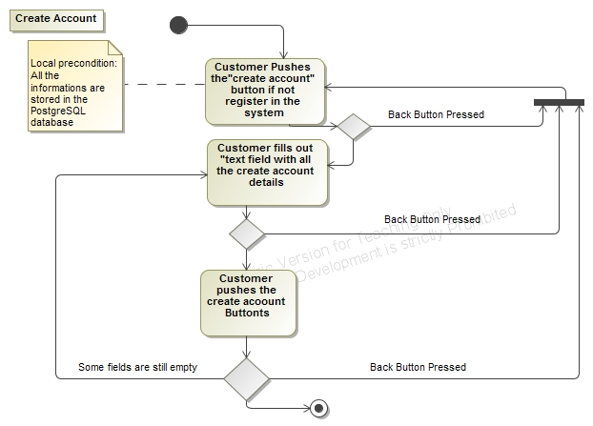

*Figure - Create Activity Diagram*

The diagram indicates that the Customer will create the account in the PostgreSQL database, according to the information provided by the customer. When all the fields has been filled, the Customer can press the “create” button, and the customer information will be stored in the PostgreSQL database.

#### Customer Login:

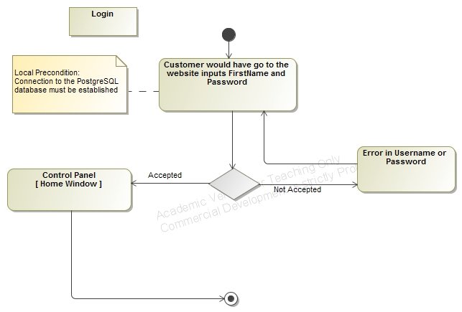

*Figure - Login Activity Diagram*

As the diagram indicates, Customer can enter FirstName and password after he/she will press the “Login” button, which calls the PostgreSQL database. After a successful connection, the Customer will hereafter have access to the home window.

#### Search Account:

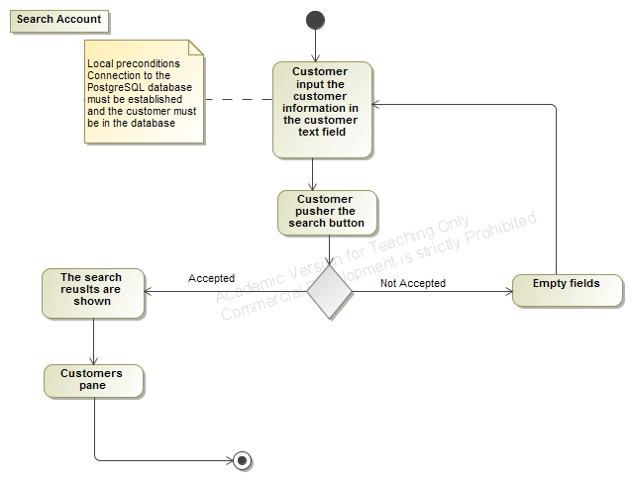

*Figure - Search Costumer Activity Diagram*

When a Customer wishes to search their account details. He/she will input the proper customer account details in the customer information text field, followed by a click on the “Search” button.

#### Update Customer:

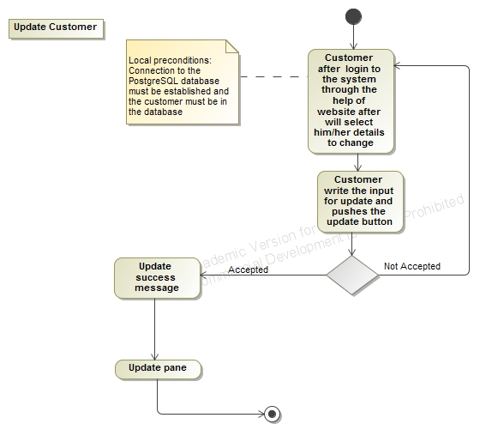

*Figure - Update Costumer Activity Diagram*

When a Customer wishes to update his/her information. He/she will select and change the text fields needed to change, followed by a click on the “update” button.

### **Proprietary protocol**

There are many factors needed to be designed to the proprietary protocol between PDA and BTC. The purpose of having this kind of protocol is to communicate between PDA and BTC and get a PDA registered as boarding on the train or bus. The first problem is how PDA makes a link for themselves on a BTC's network. Then this is decided to be used by the help of multicast. The advantage by multicast in this case is for many BTC doesn't need to know where many PDA multicast to. All PDA where wishes to receive signal can receive it, if they are only set to it. When multicast is selected is naturally to choose UDP as transport layer.

Before relationship between BTC and PDA explained, they will each especially stay short and described their roles.

**2.8 Web application**

To develop the website, JSP/Servlet are chosen to be used, rather than CGI and Applets.

**2.8.1 Analyze**

**JSP/Servlet benefits:**

-JSP is independent platform.

-JSP is faster than other alternatives.

-Less memory will be used.

-Because servlet is located on a server "Inherits" the server security.

-Servlets have built in exception act when is written in java.

**2.8.2 Why JSP/Servlet**

To the development of website, JSP/Servlets and java server page is selected. JSP/Servlets have a part of benefits in relationship to CGI and applets. Servlets is not dependent of which platform they are running on. The only requirement to the server is to set up to run in java. One of the main reasons to servlets is servlets is because they are faster than other alternatives. A servlet must only initialized one time and then is saved in memory, until server closed down or there happens a timeout. CGI program must be initialized each time when the program runs. This means, a servlet can handle a request by making a thread of each request. This means people can on use a single instance of servlet as then created a thread to each request. If CGI was used, each would require a request to each process, and this would require more resources and be slow compared with servlets. Servlets use themselves like applet of sandbox method which makes it safety and is better than CGI. Sandboxes makes to servlet not receive access to some areas where they could do damage. This means safety is much better compared with example CGI. A JSP/Servlet is always located on server side, and this means to the only server, they must be set up to go by java. There is no requirements to client on if jre must be installed. If applet is selected to develop the website. This would be a requirement to all clients should have jre installed. Another disadvantage by using applets would be that they takes further time to load when they have a GUI when need to be loaded unlike servlet.

**2.8.3 How User Interact with the website**

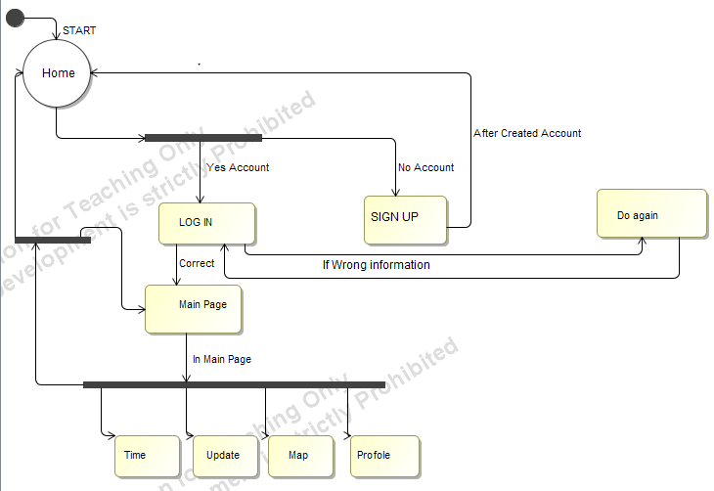

Fig. State Machine Diagram

After entered the Home page. If user’s have account. Then just by selecting Log in button can use the system. If user’s have no account then first need to create an account. Once the account has been success fully created, go back Home window and start from the Login process.

### **Home JSP**

Home JSP’s purpose is to parse the user who has logged in to a session. The result in page as long as the session live (to the user logs out), it will be stayed until logged in the JSP page, the specific user fields, and other information will be displayed and manipulated.

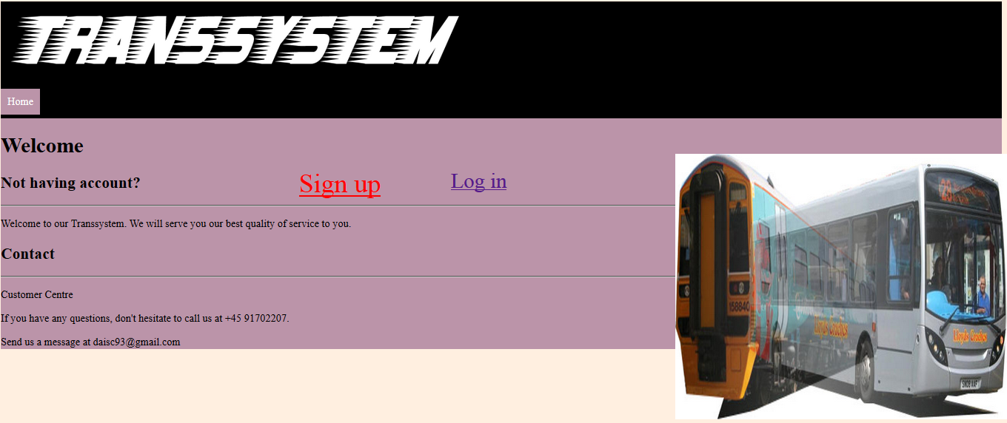

### **Sign up process**

The purpose of having **Sign up** process to create the non-existing users. If user is not registered in the system them user has to create an account.

Once the account has been successfully created, the user will be able to log in the system and can be able to use the service. User shall have to follow the given rule to creating the account.

First, the user need to click the sign up button, after clicking the button the user has to fill all the required information.

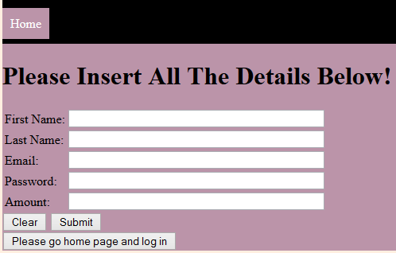

Once data of the user is correct then pop-up the message that shows the information has been inserted into database.

Like Account has been successfully created

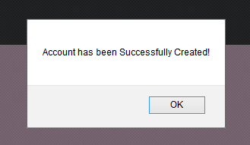

And afterwards, by clicking **Please go home page and log in** and process even further.

### **Login JSP**

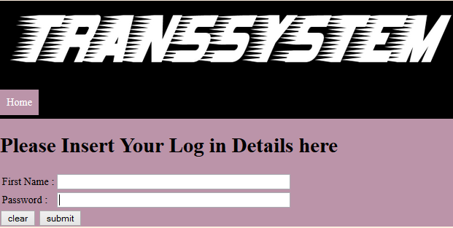

Login JSP requests a customer’s firstName and self-selected password as parameters.

The values need to be entered only if customer becomes valid through **Sign up** process that check according to the database in order to make sure that customer enters the correct data correspondent to the database. The values will be parsed to the JSP, which will then check the strings that have been input to the predefined "string" (regular expressions). If the entered data are consistent with how the type of input should be, the customer information will be found in the database by using Customer firstName and password. Then login method called from the server. It compares the user's data information with registered data information that stored in the database.

If it will not match in the database then a message will be pop-upped for you to retry, like the picture shown below,



If both of the information are matched, then the user is logged in, and will be redirected to JSP home page. As the picture shown below,

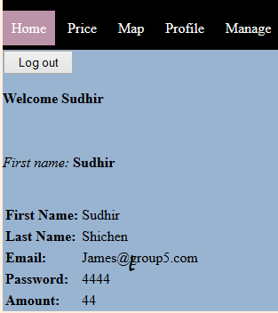

### Logout JSP

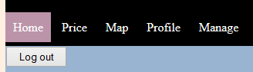

The purpose of **Logout** JSP is to put the ongoing session to be disabled,

Which means that when a user chooses to log out, he cannot go back to their profile without to log in again, thus start a new session. The reason for this is to protect the user that others will not have the access to use the use’s personal data without any permission which is for security protection.

### **Conclusion**

### Product Evaluation

We have developed a system which meets the requirements that are required to be made into the system.

1. A bus / train computer that will record the customers where they come from and when they aboard or exit the Bus/train.
2. PDA is the customer's smartphone / pocket computer
3. A proprietary protocol obtains Bus/train computer and PDA to communicate with each other.
4. A web application which the customer can use to create a user account, Update users’ profile information. Customer can also see status on his recent travels.

### Process Evaluation

Here is the project we have worked together. Our group communication was really

**Action Item List**

|  |  |
| --- | --- |
| Action | Created by |
| Design model | All |
| Requirements | All |
| Risk Analysis | All |
| Group Contract | All |
| Use cases |  |
| Class responsibilities |  |
| Sequence diagram |  |
| Design database tables |  |
| Database handling |  |
| Design PDA state machine |  |
| Implement PDA |  |
| Implement BTC |  |
| Billing system |  |
| Design custom protocol |  |
| GUI PDA |  |
| GUI BTC |  |
| Servlet |  |
| JSP |  |
| Java Script |  |
| Rejseplan implementation |  |
| Report |  |

Appendix--------------------------------------

**Shicheng/Sudhir**

For database connection part, at the beginning, we divided the work for two parts, we implemented the database connection in our own way. But for some reason, one of the group’s members implement the database connection in his way, but the principles between the two non-big-difference databases are the same. Meanwhile our implementation in our database connection was also working.